### Ikea Rocking Chair

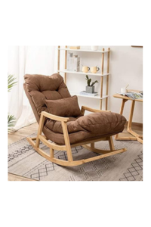

A gorgeous new addition to our new extensive range of stunning chairs comes this Fabien Lounge Chair. This gorgeous chair is completed with a leather seat , simplistic design and a metal frame. This makes it the right and best way to add some style into your lounge and living room.